

**ISSS608**

**Visual Analytics**

**REALVIS**

**Making Smart Real Estate Decisions Using Visual Analytics**

Shiny Dashboard User Guide

Prepared by:

Mak Han Ren, Sia Heng Guang, Tan Jit Kai

**Table of Contents**

**1. Overall Dashboard Navigation** 3

**2. Exploratory Data Analysis** 4

**2.1 Private Property Transaction Overview** 4

**2.1.1 Filtering by Years** 4

**2.1.2 Filtering by Property Types** 5

**2.2 Property Type Price Trends** 6

**2.2.1 Filter by Planning Region** 7

**2.2.2 Filter by Planning Area** 8

**2.2.3 Filter by Years** 9

**3. Choropleth Map** 11

**3.1 Target Analysis** 11

**3.1.1 Filter by Housing** 13

**3.1.2 Filter by Type of Sale** 14

**3.1.3 Filter by Years** 14

**4. Confirmatory Data Analysis** 16

**4.1 Landed vs Condo Price** 16

**4.2 Freehold vs Leasehold Price** 17

**4.3 Number of Floors vs Price** 17

# **1. Overall Dashboard Navigation**

Upon launching the app, users will be shown the app overview tab where users can have a deeper understanding of our project and why we chose to create an app to help users make smart real estate decisions using visual analytics.

The app contains 3 main tabs with each tab having their own sections. User can select the sections on the sidebar at the top of the screen. Here’s the overall layout of the dashboard

* Choropleth Map
  + Target Analysis
    - Filter by Type of Housing, Sale & Year
  + Exploratory Data Analysis
    - Private Property Transactions Overview
      * Filter by Year & Property Type
    - Property Type Price Trends
      * Filter by Planning Region, Planning Area & Years
  + Confirmatory Data Analysis
    - Landed vs Condo Price
    - Freehold vs Leasehold Price
    - Floors vs Price

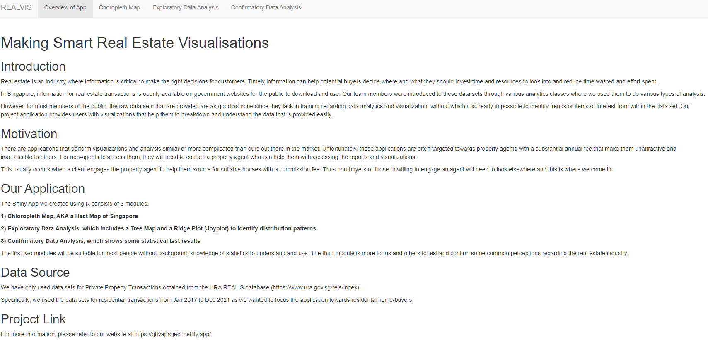

# **2. Exploratory Data Analysis**

Upon clicking on the tab, the user will be brought onto the page to perform Exploratory Data Analysis for property trends in Singapore

## **2.1 Private Property Transaction Overview**

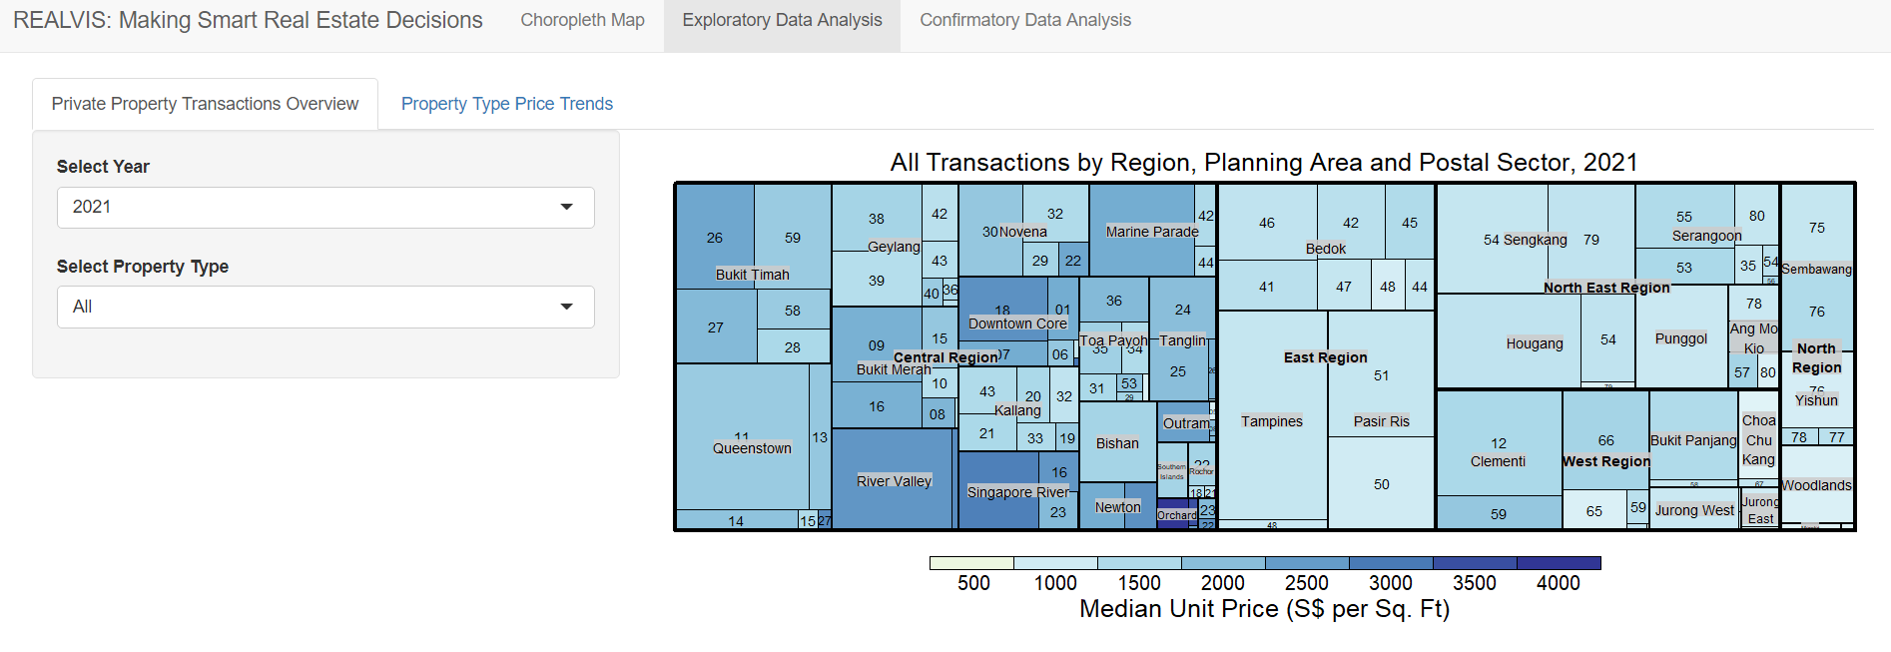

The size of the tiles indicates the number of transactions in each region, planning area and postal sector. The colour of the tiles indicates the median unit price (S$ per square foot) and the user can refer to the legend at the bottom to view the transaction trends in the each areas.

### **2.1.1 Filtering by Years**

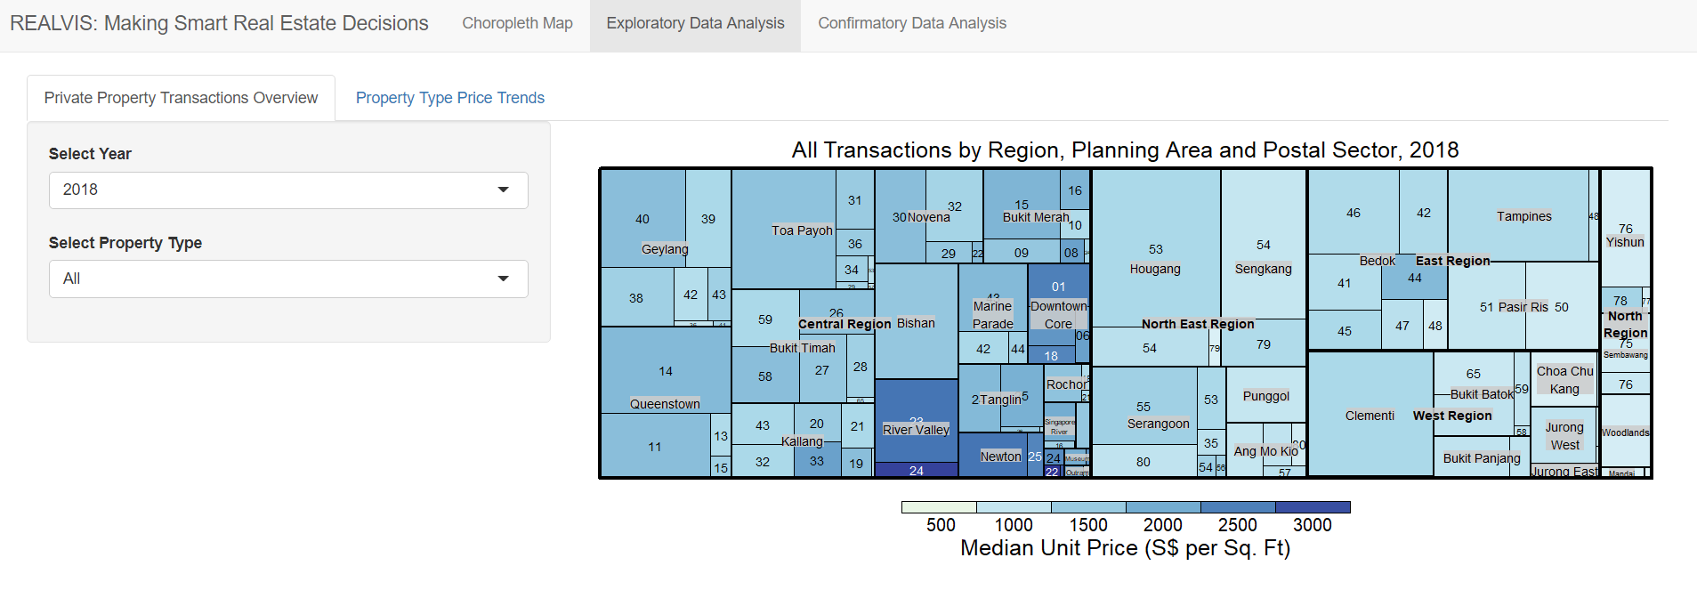

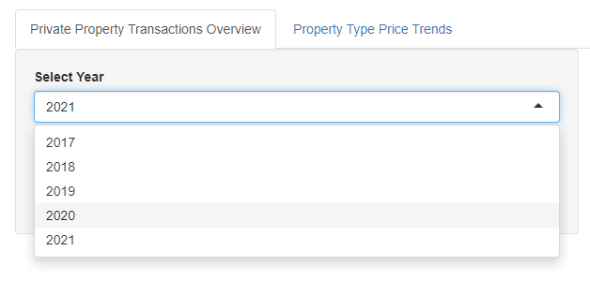

By clicking on the “Select Year” users can choose the year they are interested in from “2017 to 2021”. After selecting the year, the chart will be transformed to display transactions performed in that particular year.

### **2.1.2 Filtering by Property Types**

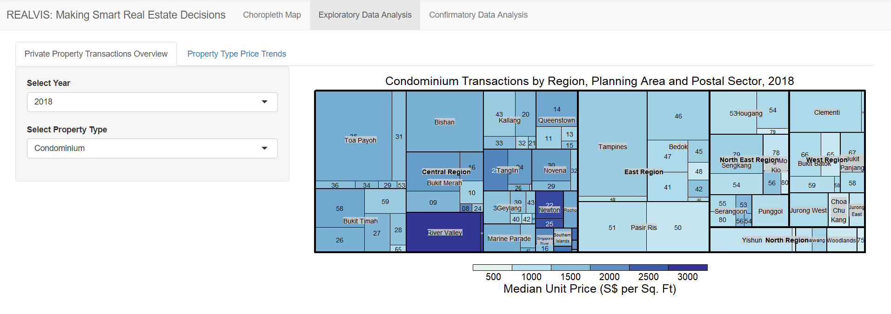

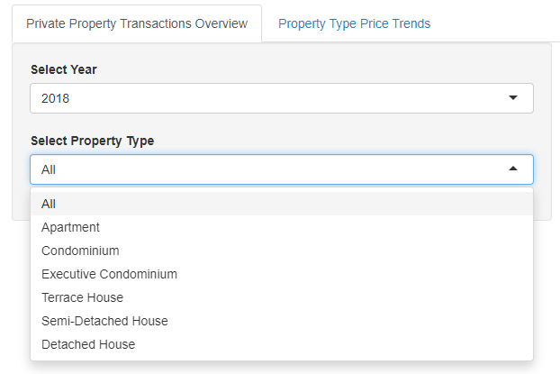

After clicking on the “Select Property Type” users can choose between “Apartment, Condominium, Executive Condominium, Terrace House, Semi-Detached House and Detached Houses.” Upon selecting their preferred property type, the chart will display transactions for that particular property type.

## **2.2 Property Type Price Trends**

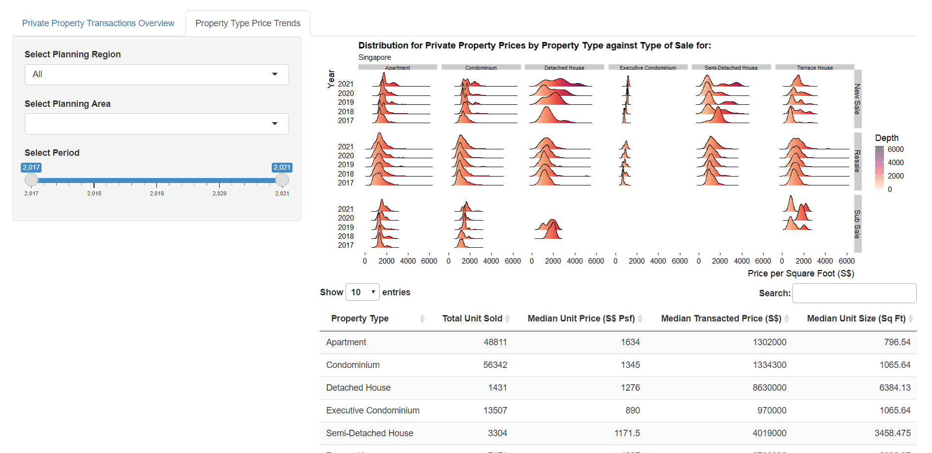

Upon clicking on the property type price trends, users will be shown a Ridge Plot displaying the distribution for private property prices by property type against type of sales. The rise or fall of the ridgelines indicate the changes in distribution over the selected period. The colours of the ridgeline plot show the number of transactions performed in that year based on the ‘Depth’ legend at the right side of the plot. When the ridgeline distribution is skewed towards the right, it indicates a higher price per square foot in transactions.

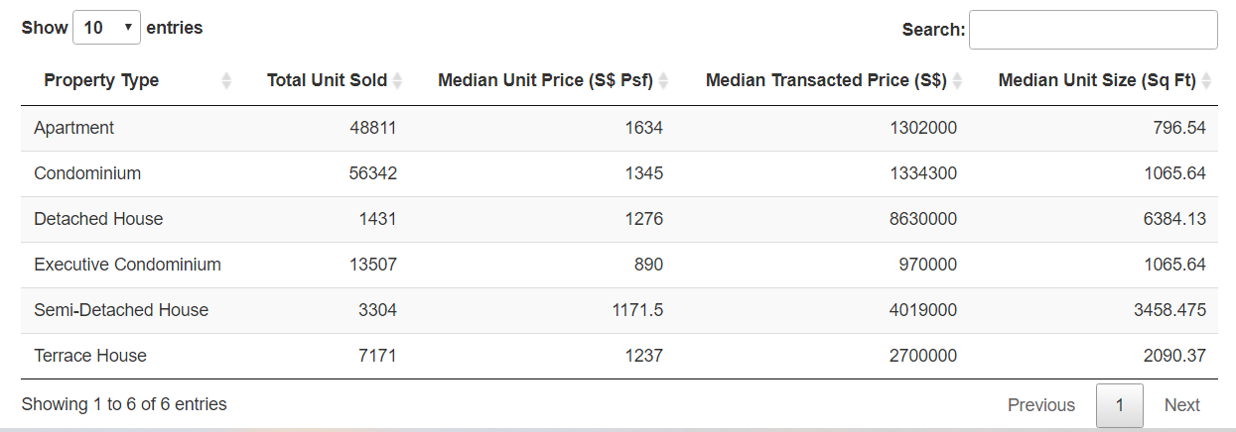

Below the ridge plot, we have a table showing various stats based on the user’s selected planning region, planning area and period. The table shows the total number of units sold, median unit price, median transacted price, median unit size for each property type.

### **2.2.1 Filter by Planning Region**

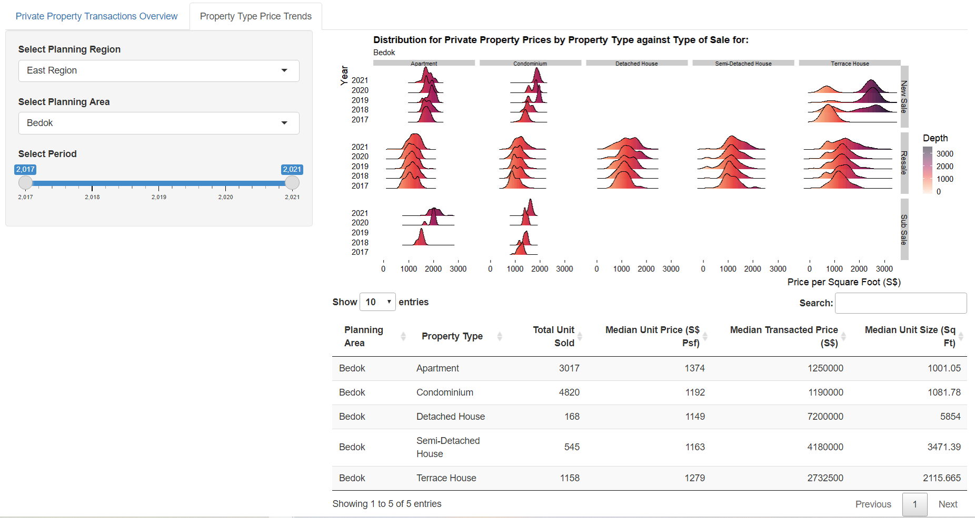

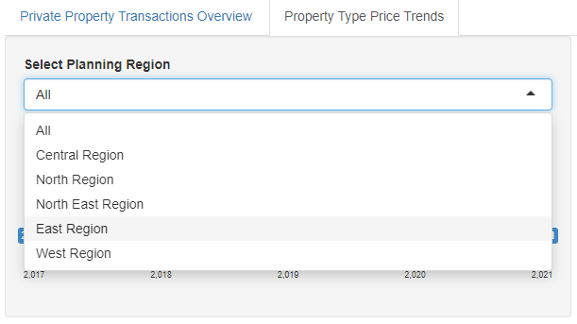

By clicking on the “Select Planning Region”, users can choose between “All, Central, North, South, East, West regions”. After selecting the Planning Region which they are interested in, the Ridge plot will transform to show the relevant distribution for private property prices by property type against type of sales. The data table below will also transform to show the total number of units sold, median unit price, median transacted price, median unit size for each property type in that planning region.

### **2.2.2 Filter by Planning Area**

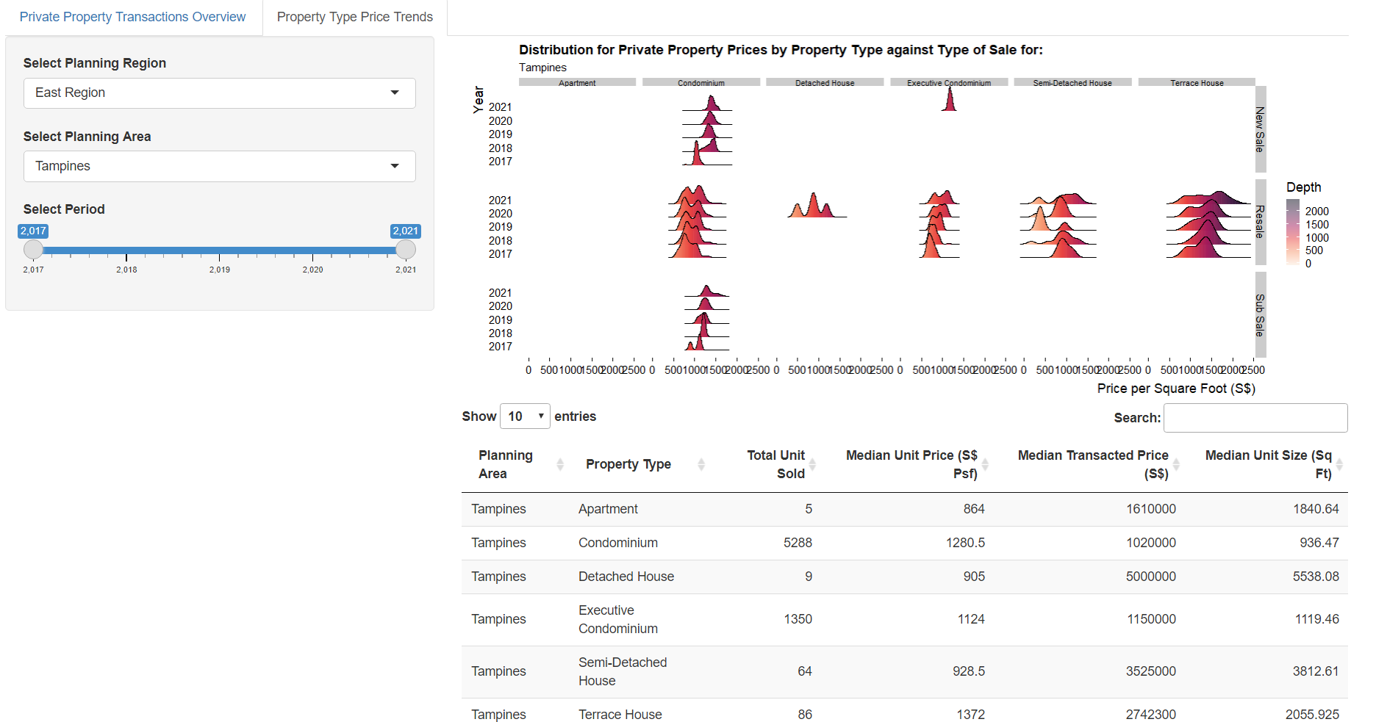

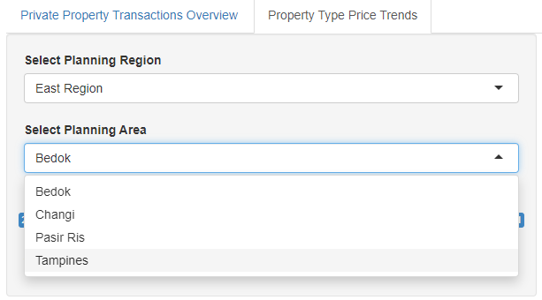

By clicking on the “Select Planning Area”, users can choose between planning areas in the region they have selected earlier. After selecting the Planning Area that they are interested in, the Ridge plot will transform to show the relevant distribution for private property prices by property type against type of sales. The data table below will also transform to show the total number of units sold, median unit price, median transacted price, median unit size for each property type in that planning area.

### **2.2.3 Filter by Years**

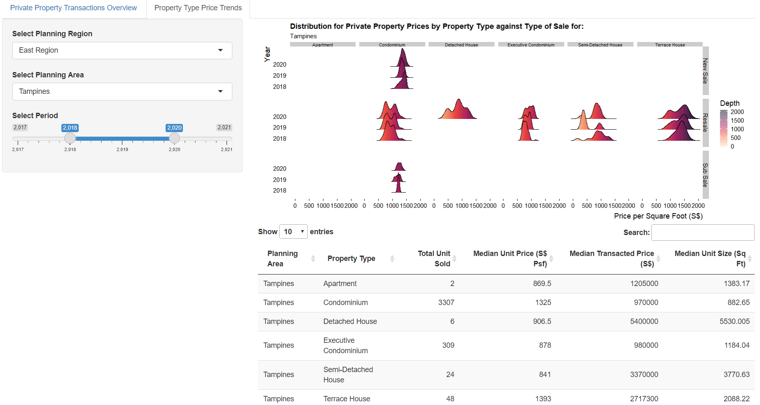

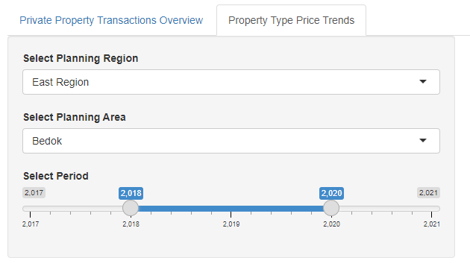

Users can drag the line on the “Select Period” slider to choose the time-period that they are interested in. After selecting the time-period that they are interested in, the Ridge plot will transform to show the relevant distribution for private property prices by property type against type of sales. The data table below will also transform to show the total number of units sold, median unit price, median transacted price, median unit size for each property type in the selected time-frame.

# **3. Choropleth Map**

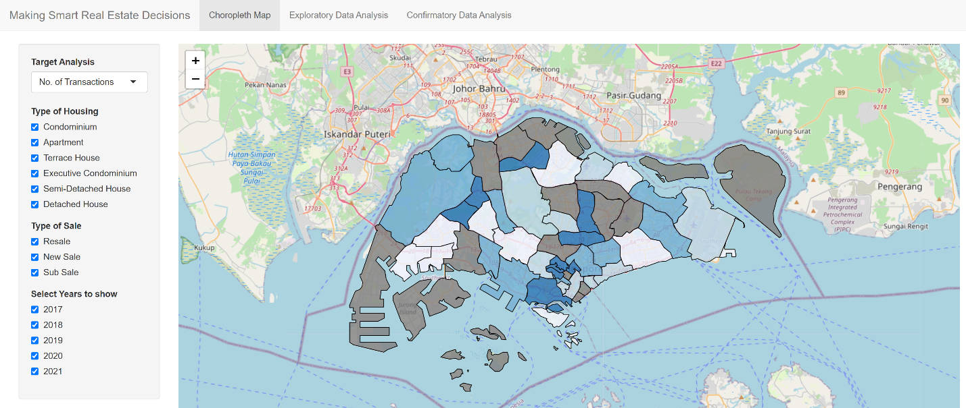

Our choropleth map is designed to show the distribution of various types of values across the various planning areas of Singapore. Users will be able to determine the value that they are wanting to see as well as filter for specific types of property, types of sale and the year. With this, they will be able to see how the distribution changes with various input changes.

For example, if we were to compare the number of condominium sales between 2020 and 2021, we would be able to see that Geylang and Clementi had a visible increase in transactions whereas the western water catchment planning area saw fewer transactions.

## **3.1 Target Analysis**

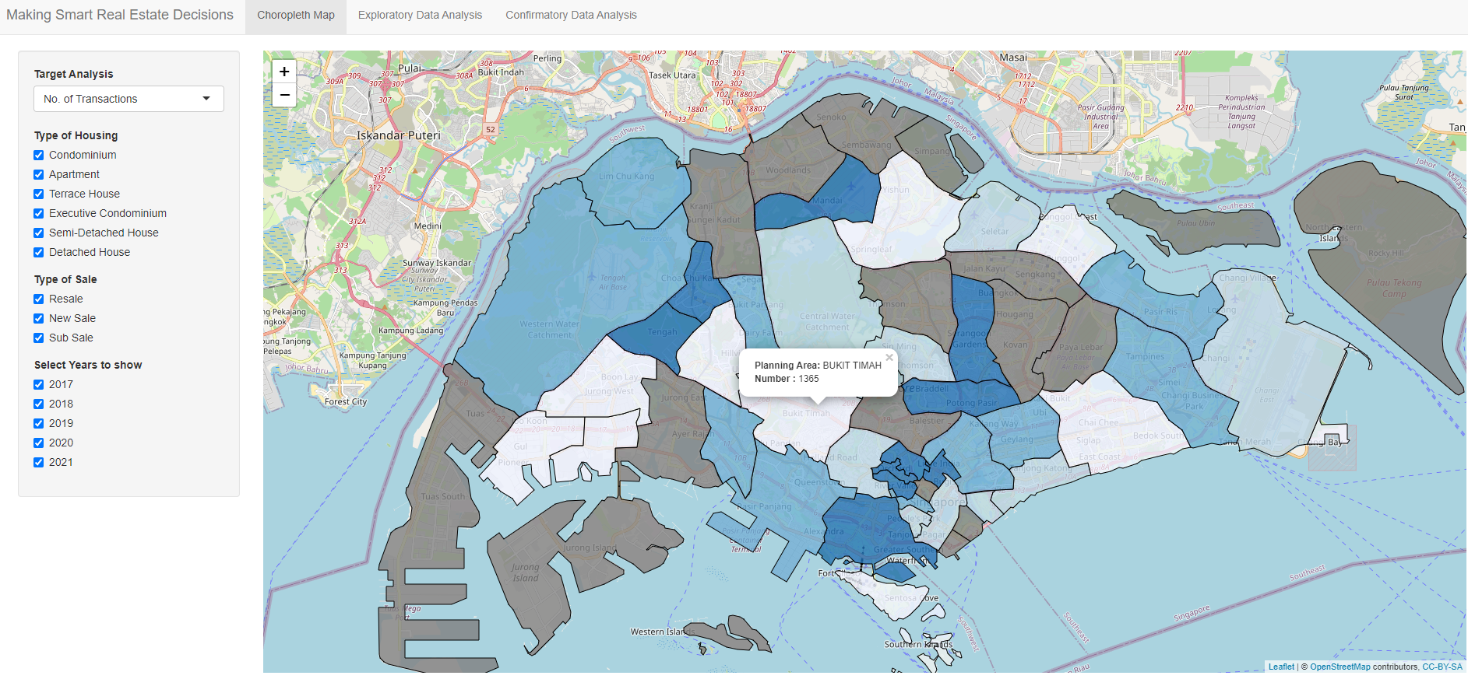

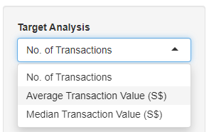

By default, users will see “Number of transactions” as the overall target analysis. By clicking on a particular planning area, users can view the total number of transactions in that planning area. By clicking on the “Target Analysis” dropdown, users can choose between “Number of transactions, Average Transaction Value and Median Transaction Value” as the target analysis.

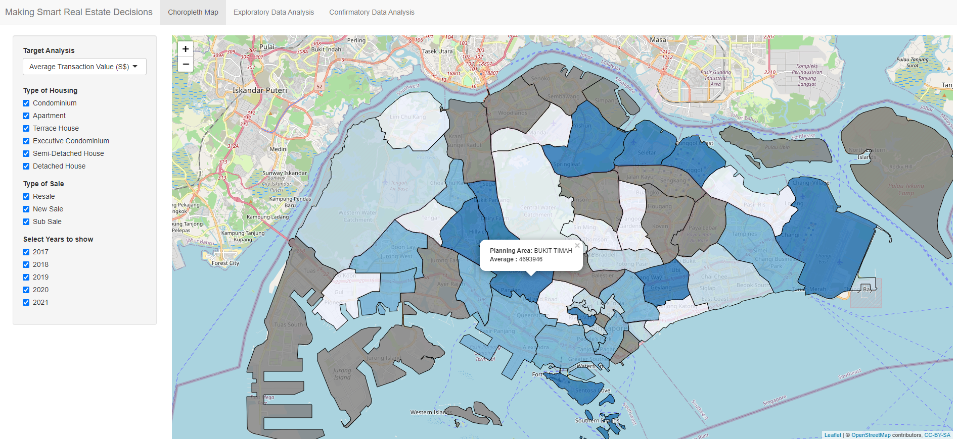

Upon changing the target analysis and clicking on the planning area they are interested in, users will then be able to see the new values, in this case the “Average Transaction Value” in that planning area.

### **3.1.1 Filter by Housing**

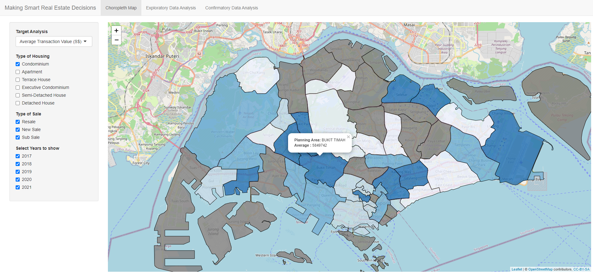

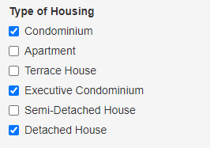

Users can select the type of housing they are interested in by ticking the checkboxes. Users can choose amongst “Apartment, Condominium, Executive Condominium, Terrace House, Semi-Detached House and Detached Houses.” Users can tick multiple checkboxes if they are interested in more than one property type.

### **3.1.2 Filter by Type of Sale**

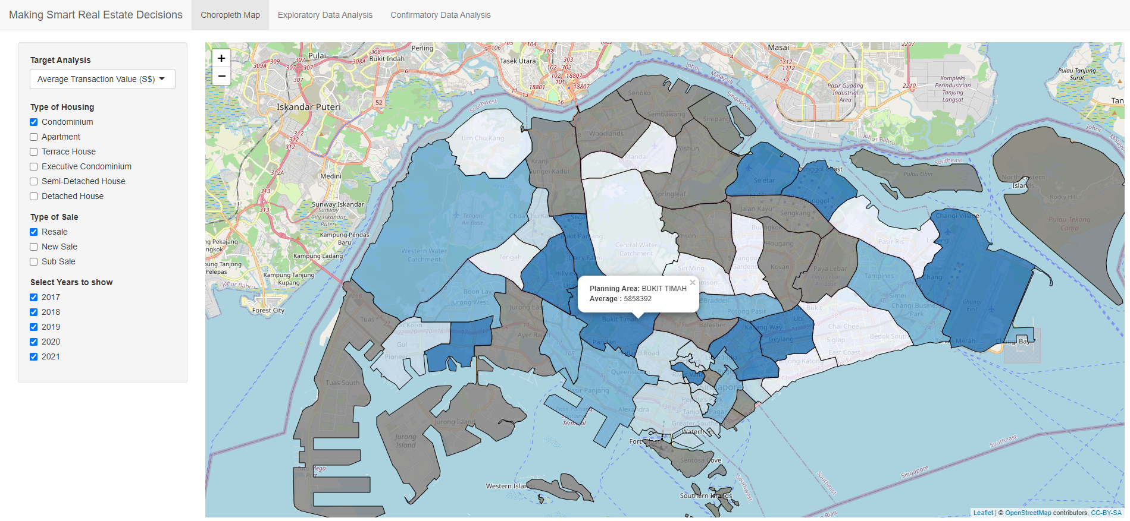

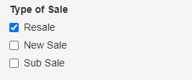

Users can select the type of sale they are interested in by ticking the checkboxes. Users can choose amongst “Resale, New Sale and Sub Sale.” Users can tick multiple checkboxes if they are interested in more than one type of sale.

### **3.1.3 Filter by Years**

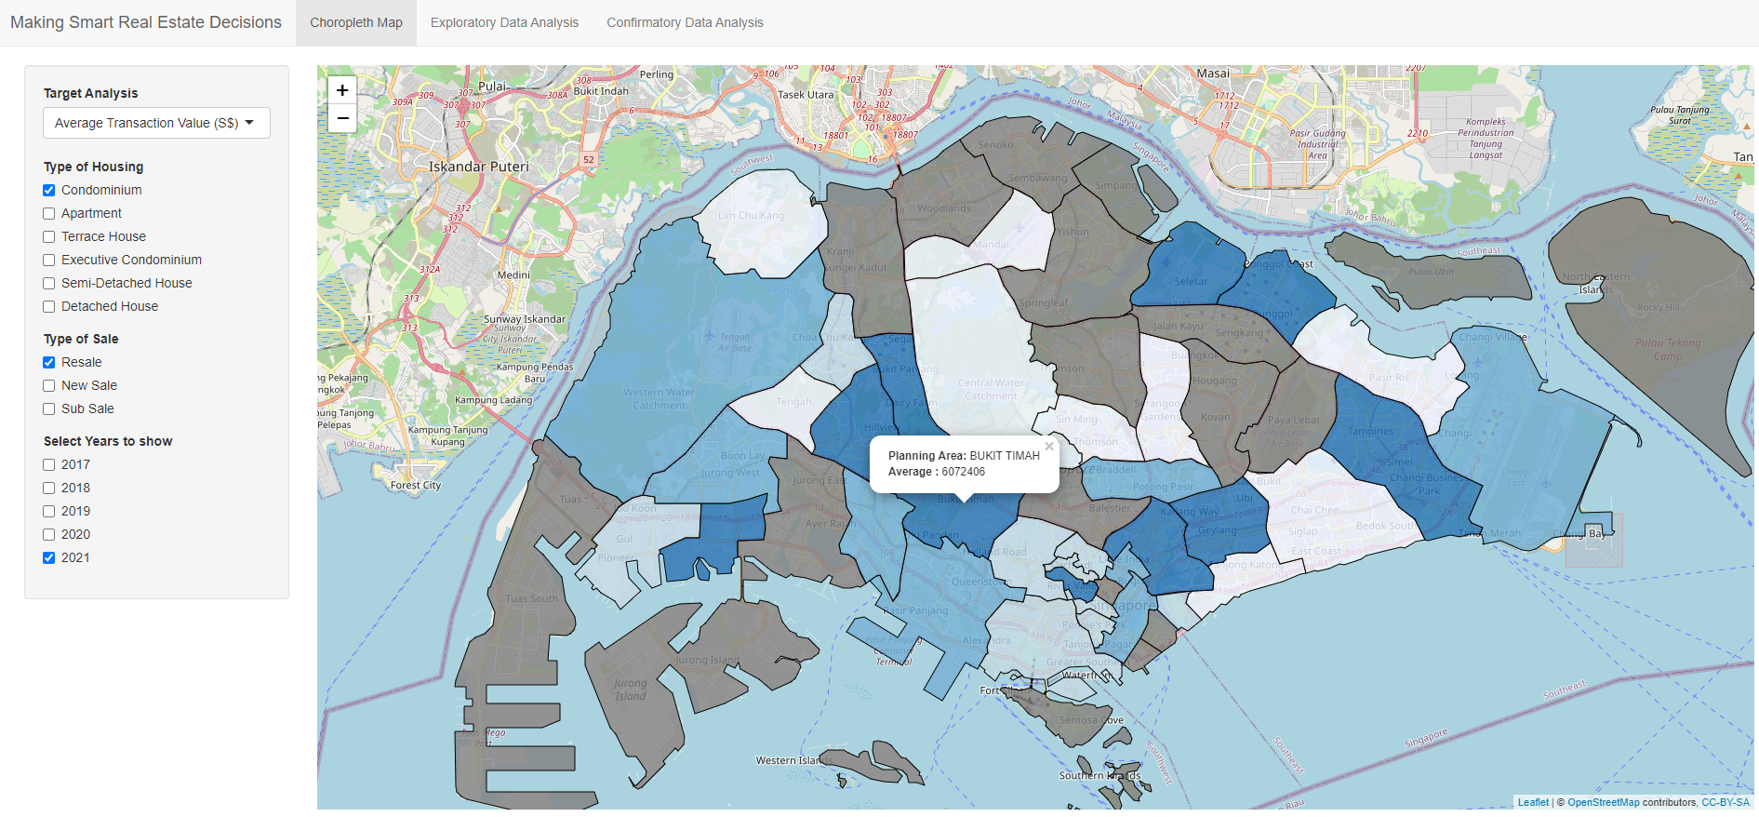

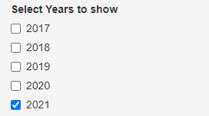

Users can select the time-period they are interested in by ticking the checkboxes. Users can choose amongst “2017, 2018, 2019, 2020 and 2021.” Users can tick multiple checkboxes if they are interested in more than year of transaction data.

# **4. Confirmatory Data Analysis**

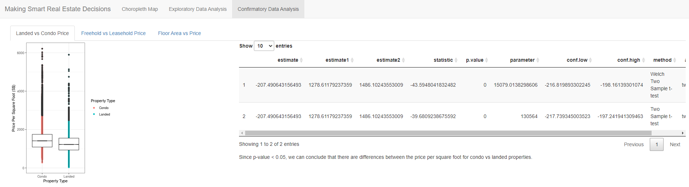

We conducted 3 tests with our data sets to find out the following:

* Whether there was a difference in price between Landed and Non-Landed properties.
* Whether there was a different in price between freehold and tenured properties.
* Whether there was a correlation between the floor number and property prices.

## **4.1 Landed vs Condo Price**



Users can view a boxplot of price per square foot for each property type. We have filtered “Condominium, Apartment and Executive Condominium” as Condo and “Terrace House, Semi-Detached House and Detached Houses” as Landed before performing our analysis.

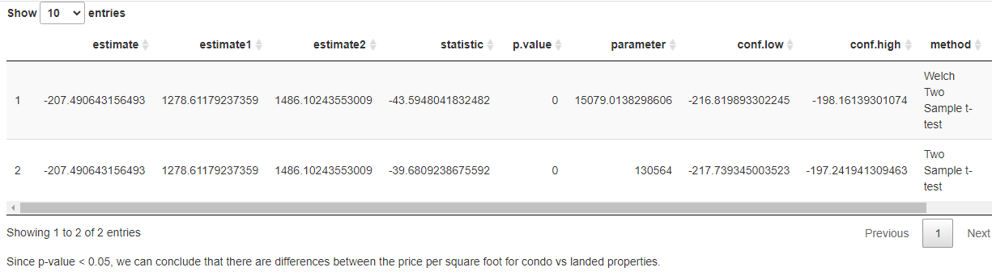

The data table shows the two different methods of t-test we conducted to determine if we can reject the null hypothesis. And given that the p-value is less than 0.05, we can conclude that there are differences between the price per square foot for condo vs landed properties.

## **4.2 Freehold vs Leasehold Price**

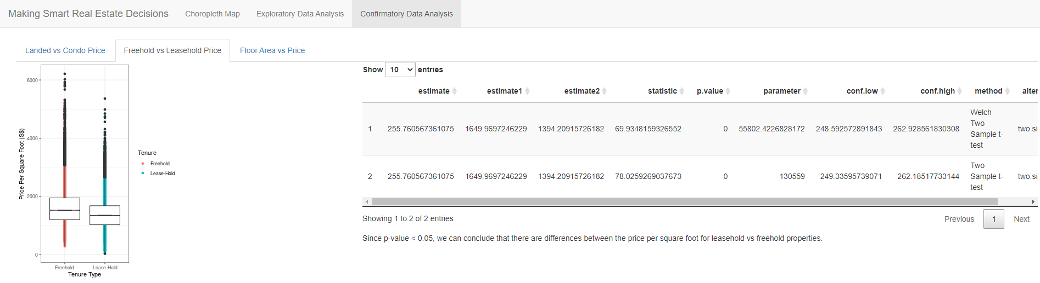

Users can view a boxplot showing the price per square foot for each tenure type. We have filtered all non-freehold tenure types into leaseholds before performing our analysis.

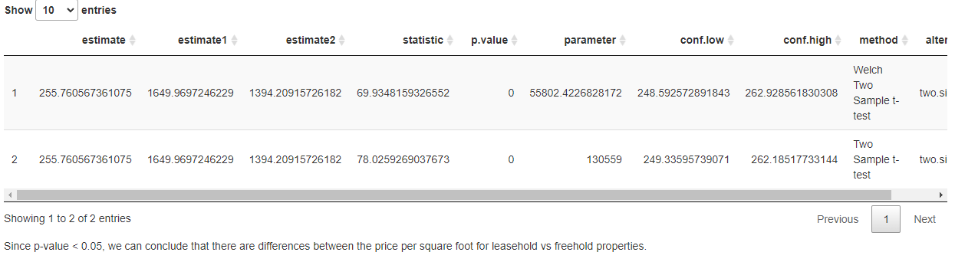

The data table shows the two different methods of t-test we conducted to determine if we can reject the null hypothesis. And given that the p-value is less than 0.05, we can conclude that there are differences between the price per square foot for leasehold vs freehold properties.

## **4.3 Number of Floors vs Price**

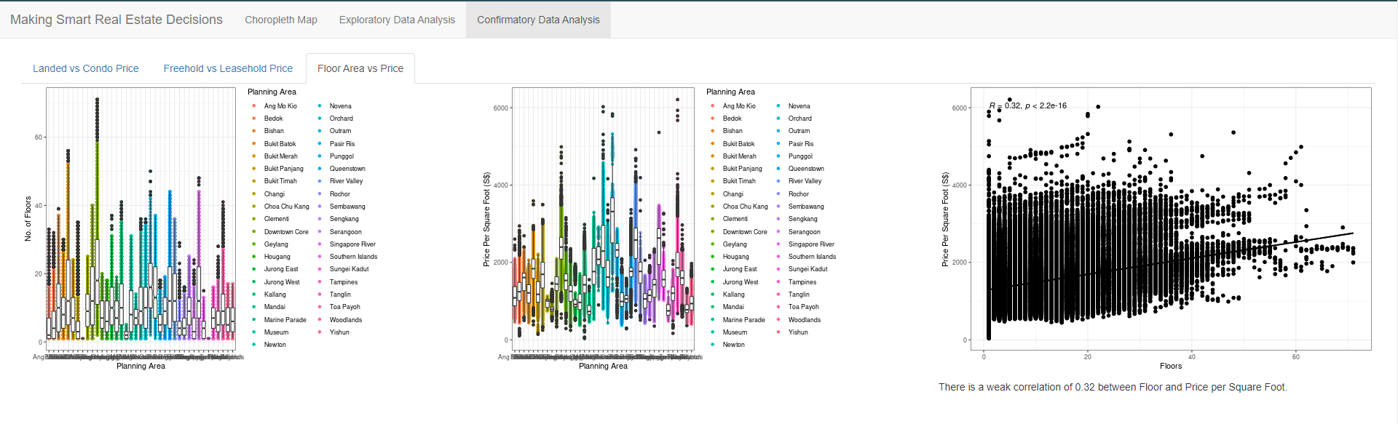

The first boxplot chart on the left shows the number of floors of properties in each planning area. We can see that Clementi has the highest average number of floors while Changi has the lowest average number of floors.

The second boxplot chart in the middle shows the price per square foot of properties in each planning area. We can see that Orchard has the highest average price per square foot while Choa Chu Kang has the lowest average price per square foot.

The scatterplot chart shows the correlation between the price per square foot of properties and the number of floors of properties. With a score of 0.32, there is a weak correlation between the price per square foot and number of floors.